Concur
Reference Guide
Travel Booking
3/22

Table of Contents
Travel Booking 2
Booking a Flight 3
Start the Search 3
Select a flight 4
Purchase the ticket 5
Booking a Car 6
Search for your Car 6
Filter the results 6
Sort the results 7
Review the results 7
Select the rental car 7
Booking a Hotel 8
Search for a Hotel 8
Change and filter search 8
Review the hotel map 8
Sort the search results (as needed) 9
Review the results 9
Select the hotel room 9
Review Travel Itinerary or Trip Details 10
Cancel Reservations 11
Change Reservations 11

Travel Booking

Utilizing the travel booking tool results in a fee. For example, $5 charge per airfare booking. Depending on utilization fees can range between $5-$35 dollars per event. The CSU has contracted with Christopherson Business Travel as our dedicated Travel Management Company. It is highly encouraged that travel segments (air, car rental, hotel) are booked in Concur to gain leverage in terms of contracted rates, consolidate spend systemwide, maintain compliant travel, and obtain travel related data that can assist with campus decision making process.

Travel must be approved before travel segments are booked in Concur.

The traveler will receive a system generated email alerting them when a request is approved. This is the traveler’s cue to login to Concur and book transportation and lodging reservations as needed and approved for a given trip.

Once logged in, travel can be booked using the “Trip Search” section of the dashboard or by selecting the Travel menu and using the Trip Search functionality there.

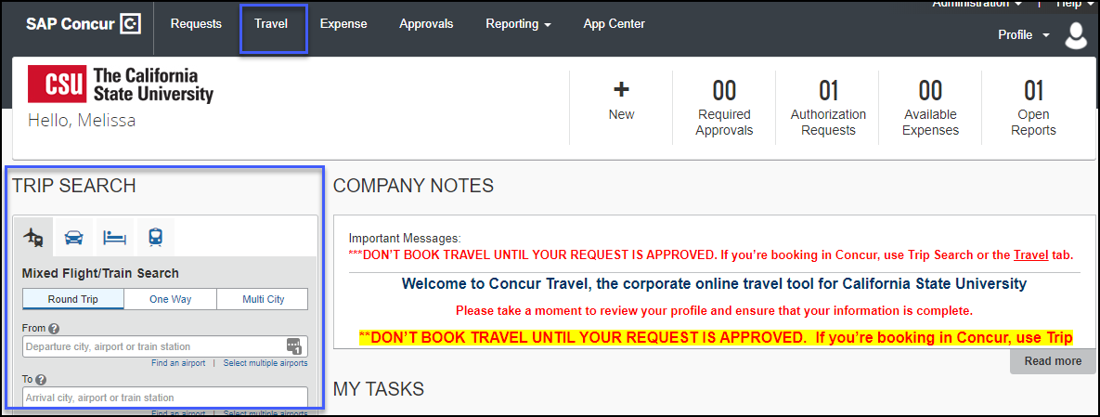
Reservations can be made separately as trip details are finalized. For example, a flight can be booked once the trip is approved and a hotel can be booked later if a conference block is full, or a rental car can be booked if needed before a trip occurs.
Please note, if you choose to utilize the services of Christopherson Business Travel, take note of your request ID before calling to ask for assistance with booking reservations. The request ID can be located by opening the request associated with the trip. Open the request, select Request Details then Request Header.
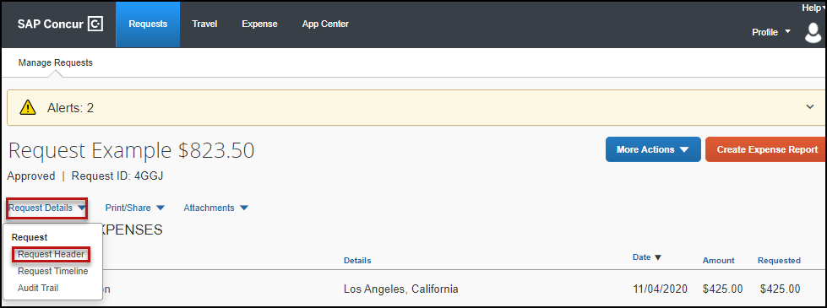

Note the Request ID for the related trip.
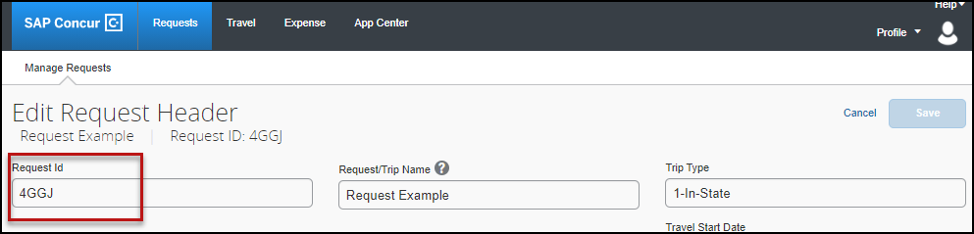

Booking a Flight
The Flight tab is on the left side of the page.
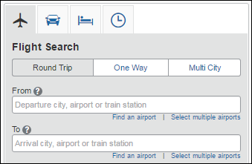
Start the Search
- Select one of the following types of flight options:
- Round Trip
- One Way
- Multi City
- In the Departure City and Arrival City fields, enter the cities for your travel. When you enter a city, airport name, or airport code, SAP Concur will automatically search for a match.
Note: Use the Find an airport and Select multiple airports links as needed.
- Click in the Departure and Return date fields, and then select the appropriate dates from the calendar. Use the remaining fields in this section to define the appropriate time range.
- Click the arrow to the right of the time window to see a graphical display of nonstop flights available for the routing and date you have selected. This allows you to adjust your search criteria, if necessary, to see/reserve nonstop flights.
Notes:
- The graphical display is based on flight schedule data. It will not show any rail options, nor can it take refundability or class of service preferences into account.
- Each green bar represents 30 minutes of time. Place your mouse pointer over a green bar to see all of the flights available for that time slot.
- If you change locations or dates, click refresh graph for more data.
- For Search flights by, select either Price or Schedule.
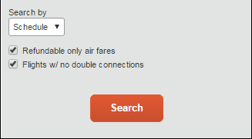
- To search only for refundable flights, click the Refundable only air fares check box.
- If necessary, uncheck the Flight w/ no double connections check box.
- Click Search.
Select a flight
- On the Flight Search results page:
- If you selected Price on the previous page, then the Shop by Fares tab is initially active.
- If you selected Schedule on the previous page, then the Depart tab is initially active.

In the following example, Price was selected on the previous page.
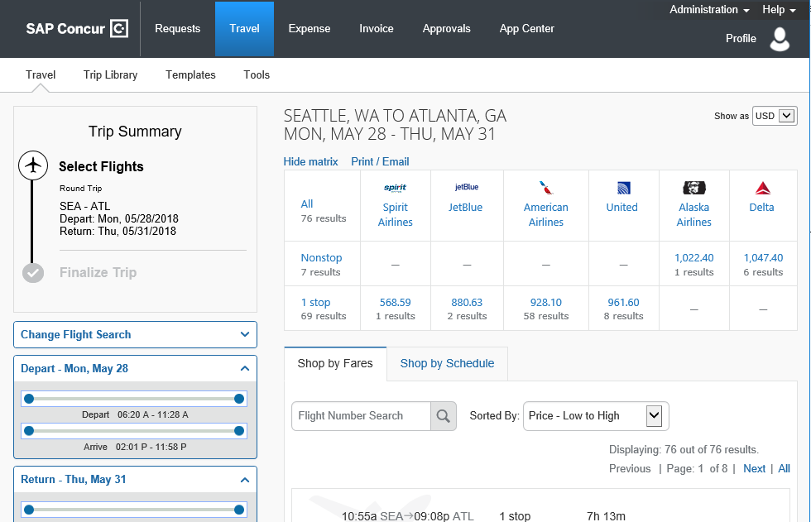
- On the Shop by Fares tab, to view additional details for the flights, click the Show all details dropdown arrow.
- To select a flight, click the fare button.
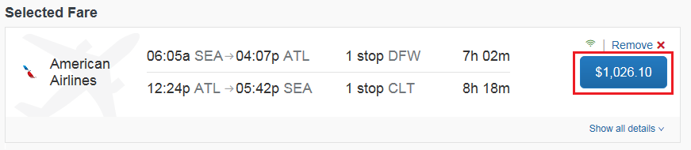
- On the Review and Reserve Flight page, review the flight details for your trip.
- On the Review and Reserve Flight page, you can do the following:
- Review your flight details
- Enter your traveler information
- Select your frequent flyer programs
- Select your seat assignment
- Review the price summary
- Select your method of payment
Note: Depending on your airfare provider, you can click the View seats map link to select your seat on the flight. Select the appropriate Available seat from the Seat Map.
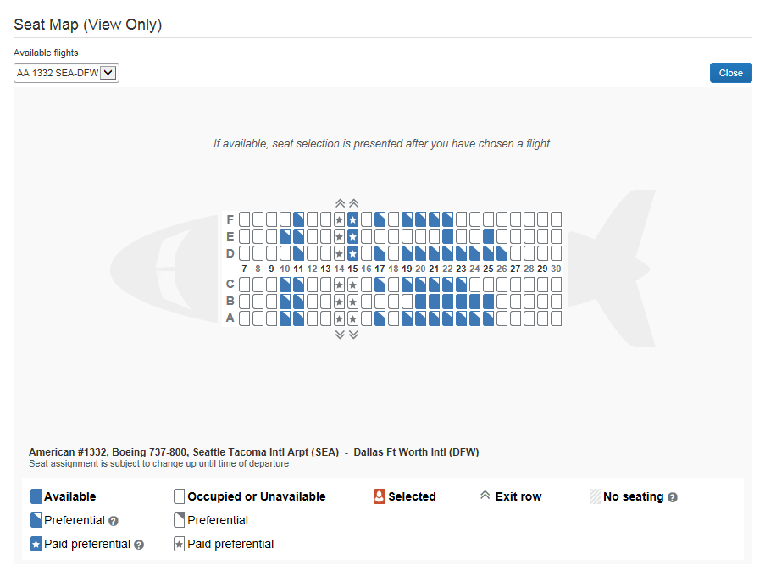
- Click Reserve Flight and Continue. If you had entered other segments on your travel request you will be prompted to complete those reservations as referenced in the Booking a Car or Booking a Hotel section. If only booking a flight, you will finalize the transaction by purchasing the ticket.
- If you need to book hotel or car rental, choose the related icon and enter reservation details. If you only need to book a flight, follow the final steps below.
Purchase the ticket
- Click Confirm Booking to send your request to your travel agent and to your manager for approval.
- Click Finish.
The Finished! screen shows your confirmation number and information to contact the travel agent.
- Click Return to Travel Center.

Booking a Car
Note: the CSU has a contract with Enterprise/National and travelers are required to use these two carriers for all rental car needs. Exceptions are only made if either carrier are not available at a destination or car inventory cannot accommodate a request.
Search for your Car
Most of the items below will feed over from the data entered at the time the travel request was populated.
- Enter your pick-up and drop-off dates and times.
- In the Pick-up car at section, select either:
- Airport Terminal, and then type the city or the Airport code.
- Off-Airport, and then enter (or search for) the location.
- Select the Return car to another location check box, as needed.
If you want to return the car to another location, additional fields will appear. Select either Airport Terminal or Off-Airport, and then enter the appropriate location.
- To see additional search preferences, click More Search Options.
- Select the Car Type.
Tip: Hold the Ctrl key to select more than one type.
- Select all of your preferences, and then click Search.
Filter the results
There are two sets of filters: The matrix at the top of the page, and the Change Car Search area on the left side of the page.
To filter your results using the Change Car Search area
- On the left side of the page, use the show and hide arrows.
- Select the Use my default credit card check box, if needed.
This is the credit card that you set up as your default in your profile.
- In the Change Car Search area:
- Change your pick-up and drop-off dates and times, and your pick-up and drop-off locations.
- Click More Search Options to select additional options such as a car type, and vendors.
- Click Search.
The new search results display.
To filter your results using the Matrix at the top of the page
- Use the grid to filter the results.
- Preferred vendors will show in the left column.
- To see a particular size of car, click the cell with the car size. The search results below will reflect that choice.
- To see cars for a particular vendor, click the cell for that vendor. The search results below will reflect that choice.
- To see cars of a particular size and a particular vendor, click the appropriate cell. The search results below will reflect that choice.

Sort the results
If you want to sort your results, click the Sorted by dropdown arrow, and then select the appropriate option.
Review the results
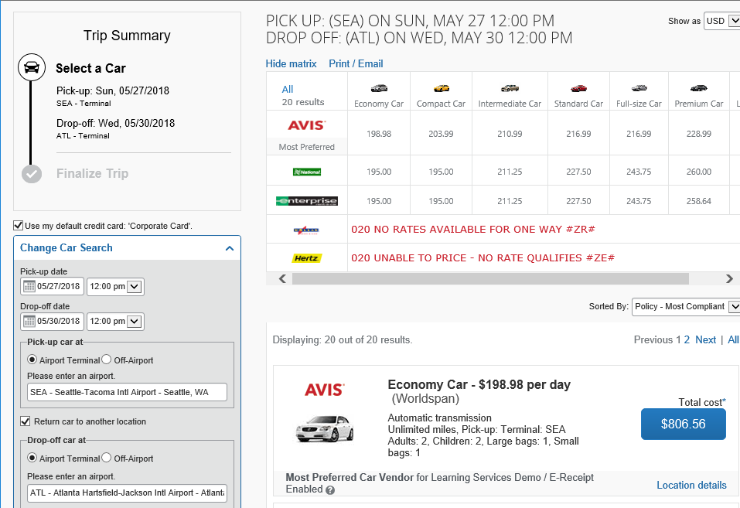
- Review the price and options.
- Click the picture of the car (if available) to see a larger picture as well as passenger and luggage capacity.
- Click Location details for more information about the available options.
Select the rental car
- Click the Total cost button.
Note that the color of the Total cost button reflects policy compliance.
The Review and Reserve Car page appears.
- Review the details for accuracy.
- Select a rental car program, as needed.
- Select a method of payment, if necessary.
- Click Reserve Car and Continue.

Booking a Hotel
Search for a Hotel
Most of the items below will feed over from the data entered at the time the travel request was populated.
- Enter the Check-in and Check-out Dates (or click in the fields to use the calendar).
- Enter the search radius.
- Choose to search near an Airport, Address, Company Location, or Reference point / Zip Code, and then enter the appropriate information in the available fields.
- If you will be using more than one hotel on your trip, select the Add Another Hotel check box.
Additional fields will appear. The Check-in Date field for the second hotel is automatically populated with the check-out date of the first hotel. Change the date as necessary.
- Click Search.
Change and filter search
- In the Change search area:
- Change your check-in and check-out dates, and your hotel location.
- Click Search.
Travel displays the new results.
- Use the slider in the Price area to narrow your search.
- In the Hotel chain area, select the appropriate hotels.
- In the Hotel Amenities area, select the appropriate options.
Review the hotel map
- Review the hotel map.
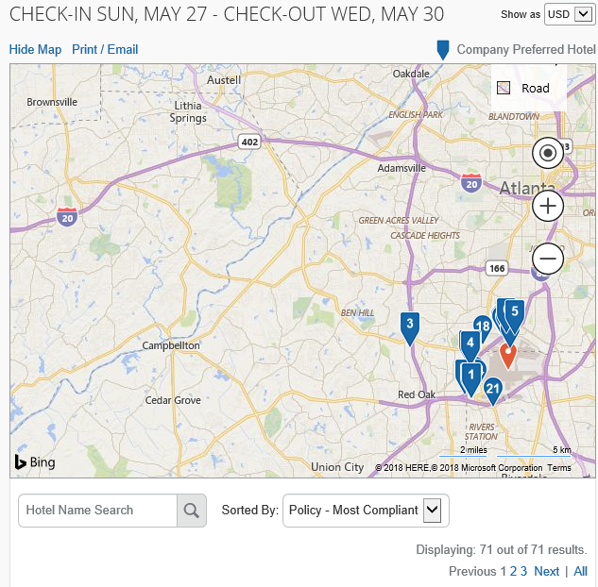
- Click any blue icon to see specific hotel information. Use your mouse to zoom, and move the map, as needed.
The red icon indicates your reference point, and the blue icon shows your company’s preferred hotels.

Sort the search results (as needed)
- Below the map, use the Hotel Name Search and Sorted By fields to sort the results.
Review the results
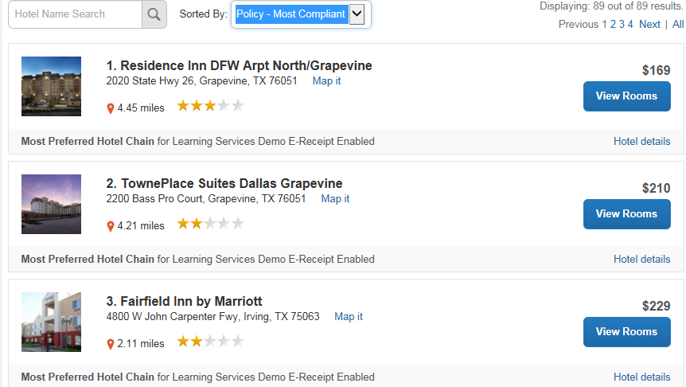
A picture as well as the name, address, rating stars, and price range appears.
- Click the picture to see more images.
- Click Hotel details to see contact information, street address, cancellation policy, and information about the facility.
- Click View Rooms to see:
- The available room options and rates
- Other amenities per room/rate
- Rules and cancellation policy
Select the hotel room
- Click the Cost button next to the room that you want to reserve.
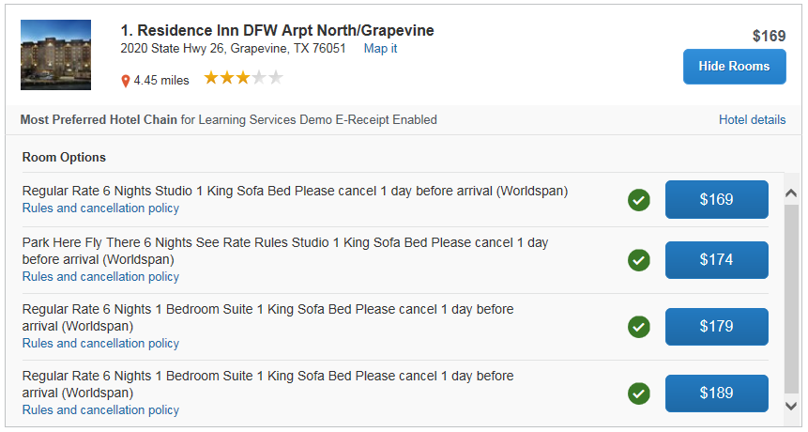
Only select state rates if noted, not governmental rates that will require Federal credentials.
The Review and Reserve Hotel page appears. Navigate through the page and:
- Review or modify the room preferences.
- Verify or modify the guest and program information.
- Review the price summary.
- Select a method of payment, if available, as defined by your company's configuration.
- Review and accept the rate details and cancellation policy.
- Select the I agree to the hotel’s rate rules, restrictions, and cancellation policy check box.
- Click Reserve Hotel and Continue.

Review Travel Itinerary/Trip Details
Trip details can be reviewed at a later date as needed or in the case where reservations need to be cancelled.

Review Itinerary
Navigate to the Travel menu, select Trip Library and open the trip itinerary that you want to review.
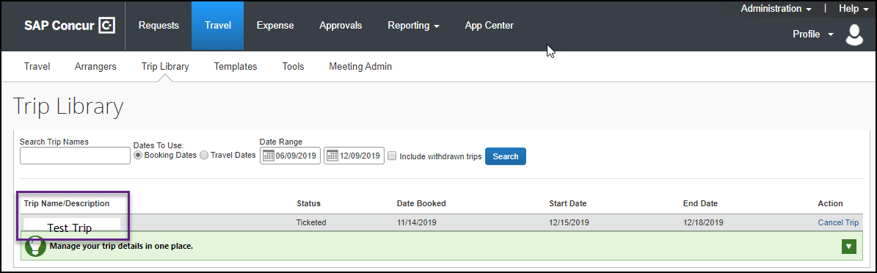
Reservation details will be displayed in a separate window.
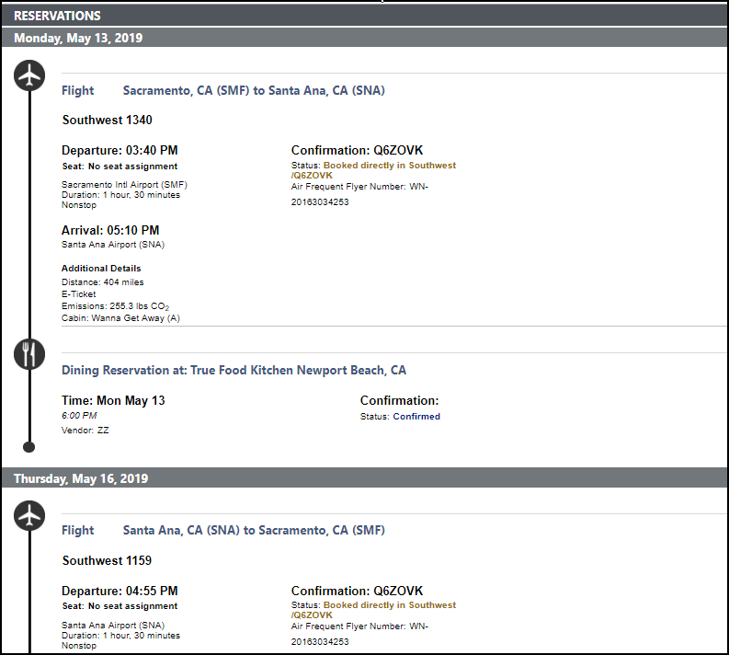

Cancel Reservation
This step can be done by the traveler or delegate. The entire trip can be canceled or certain segments can be canceled as needed.
Select the Travel tab, then select Trip Library. Select “Cancel Trip” hyperlink for the appropriate trip. Follow prompts to fully cancel reservations and close the travel element of the previously booked trip.

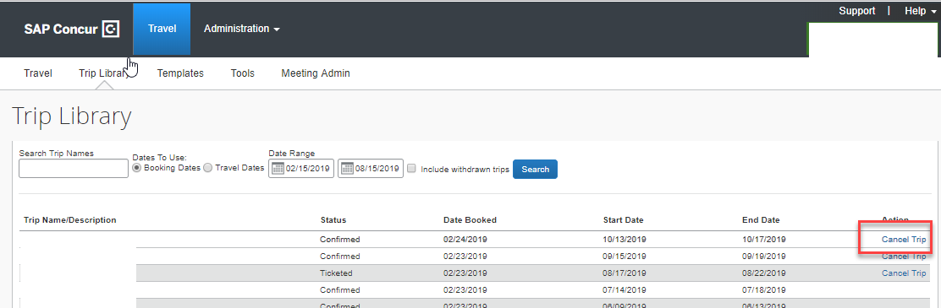

Change Reservation
There may be a need to alter reservations previously booked in Concur. Open the particular trip to see the itinerary.
Select the Change hyperlink (on the right hand side near the segment) and alter as needed.

Example of changing a previously booked flight.
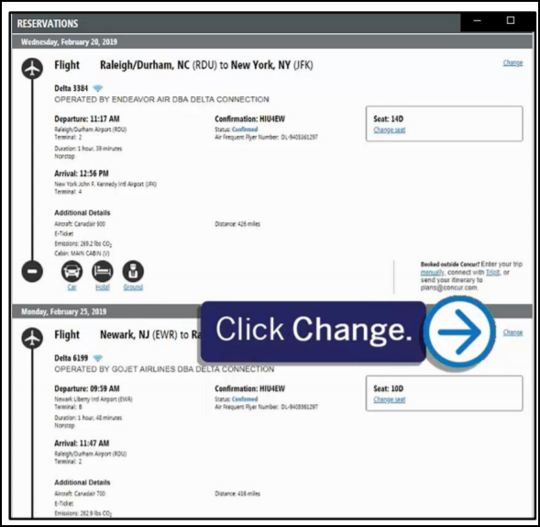

Changing departure date should flow through to other reservations (i.e. car or hotel booked for the trip, which can be overwritten if needed)
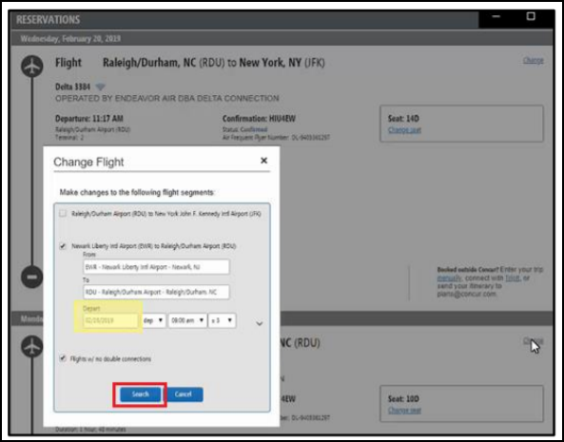

Flight information will be summarized to show the difference between previous reservation and new reservation.
If changing carriers you will need to cancel the previously booked flight and reserve a new flight with an alternate carrier.

