Concur
Reference Guide
Non-Employee Travel
03/22

Table of Contents
Concur Non-Employee Travel 2
Student Travelers 2
Guest Travelers 4

Student Travelers

Creating a Student Travel Request
If you are arranging travel for a student, email apinvoice@sonoma.edu with the student name, address, SSU ID, SSU email, and phone number. For faster reimbursement via direct deposit, the student can download and submit a Direct Deposit Authorization form through AP secure upload.
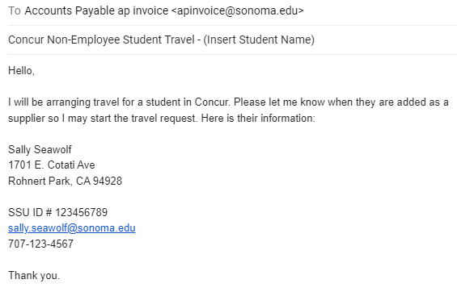
Once you receive an email confirming the student was added, log into SAP Concur.
To create a request:
- Click Requests on the header toolbar, and then select the Create New Request tile on the request page.
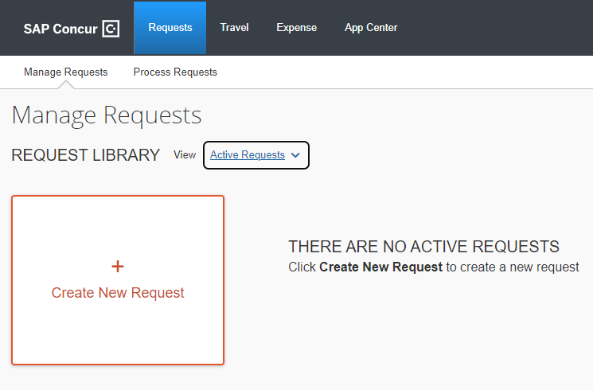

- Complete all required fields with a red asterisk:
  - Click the dropdown for Request Policy and select “CSU-Non-Employee Request Policy”.
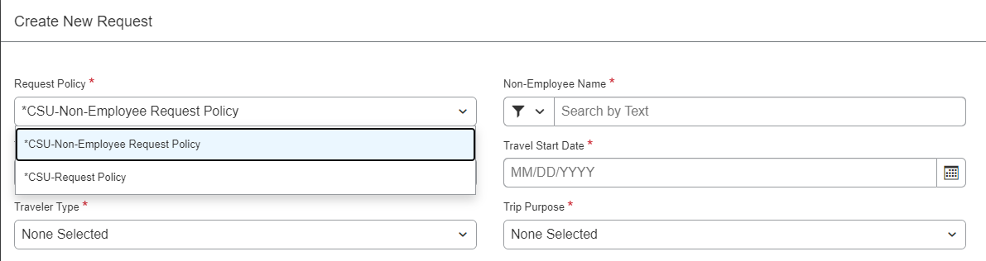
  - Enter the student’s name into the Non-Employee Name section.
  - Select “Student” as the Traveler Type from the drop down selection.
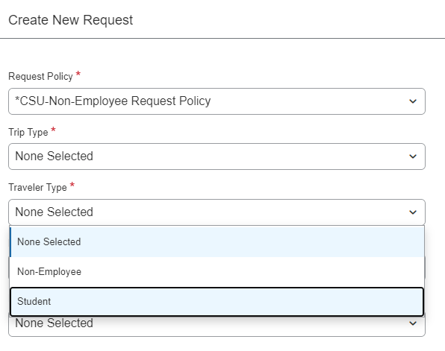
  - Continue to fill out pertinent request information as you would for a standard request.
- Select Create in the lower right-hand corner of the screen.
After the request is submitted, approved, and the travel has occurred, create an expense report from the request and process as normal.

Non-Employee Guest Travelers

Creating a Non-Vendor Guest Travel Request (Such as Candidate)
Before creating a travel expense, the guest traveler must complete a 204 Vendor Data Record Form in order for AP to create a Supplier ID. The 204 Form can be found on the Accounts Payable Forms & Policies page. A W9 cannot be accepted in place of the 204.
Please note: Due to level one data on the form, the completed the 204 must never be emailed. The traveler must upload the form to the Secure Upload Page.
For non-US residents, before travel can occur, the AP office must review their Foreign National Data Collection Form and W-8BEN in addition to the 204. The Supplier ID must be created before any travel expense can be submitted.
Department monitors CFS for supplier creation. Once the guest has been added as a supplier, email apinvoice@sonoma.edu the supplier name, and request Concur access. Once AP replies, log into SAP Concur to begin an Expense Report. Please note: No request is needed for guest travelers.

To create a report:
- Click Expense on the header toolbar, and then select the Create New Report tile on the request page.
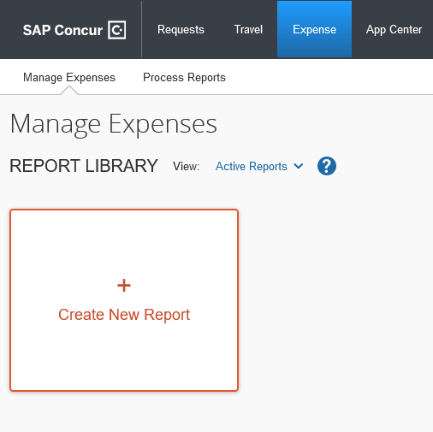
- Complete all required fields with a red asterisk:
  - Click the dropdown for Request Policy and select “CSU-Non-Employee Request Policy”.
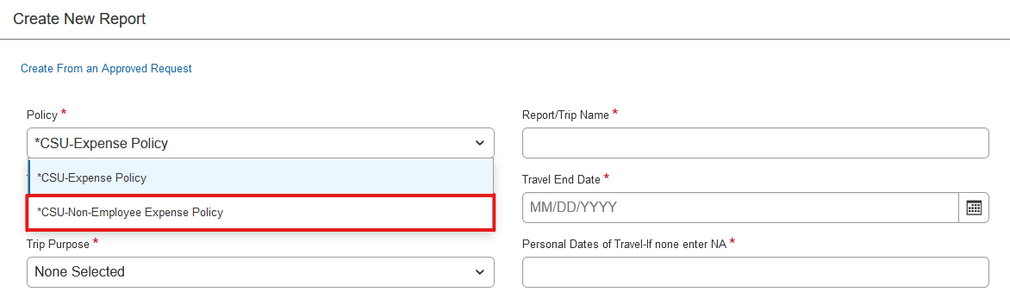

  - Select the business unit as (SOCMP) SOCMP - Sonoma State University, then you can select the guest from the Non-Employee Name drop down.
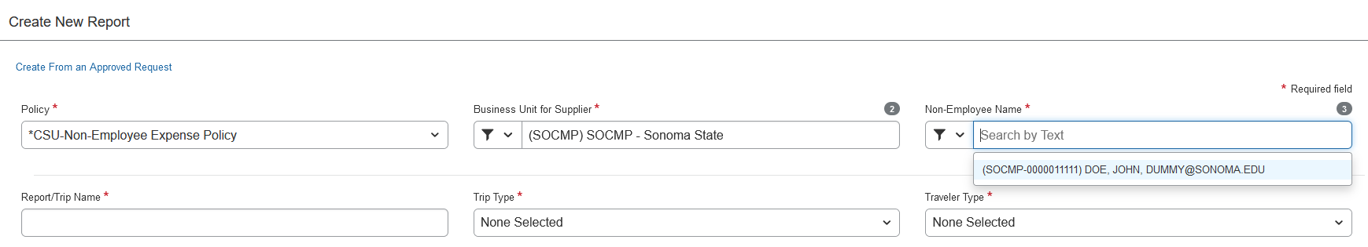
  - Select “Non-Employee” from the Traveler Type drop down menu.
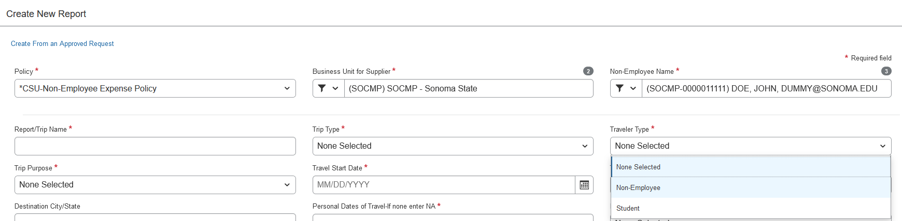
  - Continue to fill out pertinent request information as you would for a standard request.
- Select Create in the lower right-hand corner of the screen.
When the Expense Report is created, you can go in and add/itemize expenses as you would for a standard expense report.

